**THE SMARTY’S BUS BRANDING SAGA**

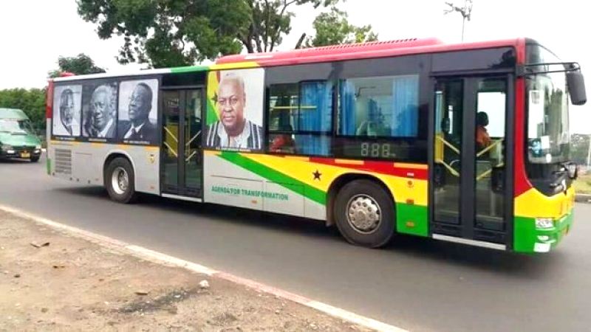*A clear case of bad governance, waste, corruption and non-transparent government.*

The recent Smarty’s bus branding saga provides clear case of bad governance, waste of taxpayers’ monies, corruption, non-transparency and weak government response to corruption that has become typical in these seven years of NDC governance. Details emerging from the scandalous GH¢3.6 million branding contract for 116 Metro Mass Transit (MMT) buses indicate that it (contract) was awarded to Selassie Ibrahim, an activist of the ruling National Democratic Congress (NDC).  
  
**THE DECISION**

In the light of the acute poverty and dire hardships in Ghana, the decision to invest taxpayer’s monies into putting President Mahama's picture and pictures of his fourth republic predecessors, on hundreds of public buses is a clear case of misplaced priority and insensitive decision making that is out of touch with the real needs of the Ghanaian people. The space on those buses could have been readily taken out by advertising companies who would have paid monies in to the national treasury. The decision to rather put President Mahama's photos on the buses has not only deprived the poor taxpayer of good money, but also actually caused the taxpayer to pay out millions of Ghana Cedis.

**THE EXCUSE**  
The excuse for this decision to put the photos of President Mahama and the other fourth republic presidents on the buses is ludicrous. This was to recognize and enumerate their contributions to Ghana’s progress. Nevertheless, the contributions of Mahama towards the country Ghana had just began and the mere idea of his picture on the bus raises questions, since he is not an ex-president but the ruling president now. But rather strangely, his picture is even more prominent than those who have finished their contribution and left. In fact, the others are in black and white (and not very visible) and his in full colour! It is therefore clear that this venture is nothing more than a poor venture to project President Mahama ahead of the 2016 elections, and have the poor taxpayer pay for it!! This could mean that the project was poorly done to and it was a means to project President Mahama for the elections on December 7th this year.

**CORRUPTION**  
The decision of the NDC government shows awful bad judgment. It causes the poor taxpayer to forfeit revenue. It reprimands the poor taxpayer to lose money in payment, all in a bit to project President Mahama. Furthermore, the execution of this very bad decision was mired in wanton corruption, and brazen illegality. According to the Attorney General, even as the poor Ghanaian taxpayer was made to pay for this horribly misplaced decision, the taxpayer should not have paid more than GHC 1.7 million. Instead, the poor taxpayer was made to pay an extra Gh 1.9 million (19 billion old Cedis) for no work done whatsoever. This wanton dissipation and clear looting of public funds take place at a time when Korle Bu is closing major units for lack of Gh 700, 000 to buy medical consumables.

The detailed Pro-forma invoice of the controversial GH¢3.6 million branding contract is believed was submitted to Minister of Transport Dzifa Attivor by Smarty’s Management and Productions, a company reportedly owned by the renowned actress, Selassie Ibrahim, wife of Ibrahim Adams. Dated July 17, 2015, the invoice, believed to have been signed by the accounts officer of the company, according to media reports making the rounds yesterday, details how the grand total of the controversial amount was arrived at. On the invoice sighted by DAILY GUIDE, the material cost for spraying each of the buses in red, yellow and green colours was pegged at GH¢14,210.00. Until the media intercepted the invoice, the government did not make public the document for some unknown reasons.

Critical Thinkers, in a statement released and jointly signed by its spokespersons, Kwadwo Akowuah Acheampong, Nana Kwadwo Akwaa, Kwabena Asemani Afari and Nana Kyei Baffour, called on the Auditor-General and the Public Accounts Committee of Parliament to institute an investigation into what made the country incur such a colossal cost on just the branding of the vehicles at a time the national economy is struggling to survive as a result of mismanagement and wanton corruption within public circles. The Minority Leader in Parliament, Osei Kyei-Mensah-Bonsu, raised the issue raised in Parliament on Tuesday apparently accusing President Mahama of presiding over a corrupt regime spelt out the incompetent governance by the NDC under the reign of John Dramani Mahama.

This issue still baffles the minds of Ghanaians. How can just rebranding of a bus cost us over GH¢31,000? But the Minister of Transport, Dzifa Attivor, is reported to have stated that “branding 116 buses cost GH¢3.6m because artistic work is generally expensive,” subtly insulting the intelligence of Ghanaians.

**REFERENCE**

* <https://www.google.com.gh/#q=The+Smarty+Bus+Branding+Case> MyJoyOnline webpage
* <http://www.ghanaweb.com/GhanaHomePage/features/The-smarttys-bus-branding-saga-416244> GhanaWebpage
* <https://www.youtube.com/watch?v=qcRUkDxocpE> YouTube Video (Bus Branding Case)
* National Newspapers: Daily Graphic & Daily Guide.